**Java Web开发**

**实验七**

**作业报告**

|  |  |
| --- | --- |
| 学 院 | 计算机 |
| 所在系 班 级 | 2017软件工程系09班 |
| 学 号 姓 名 | 莫君炜 |
| 指 导 教 师 | 郭晓燕 |
| 完 成 时 间 | 2018年4月- |

# 实验题目

1、页面输入收入，得到相应的缴纳税收

要求：Jsp提交收入，显示结果（可一个页面也可两个页面）。编写一个JavaBean计算税收，并在JSP页面输出结果。

计算方法：全月应纳税所得额＝月收入－1600元

级数 全月应纳税所得额 税率% 速算扣除法(元)

1 dr <=500 5 0

2 500 <dr<=3000 10 25

3 3000 < dr <=5000 15 125

4 5000 < dr <=20000 20 375

5 20,000 < dr <=40000 25 1375

6 40,000 < dr <=60,000 30 3375

7 60,000 < dr <=80,000 35 6375   
8 80,000 < dr <=100,000 40 10375   
9 dr >100,000元 45 15375

如：月收入3000，则（3000-1600）*10%-25=115，因为3000-1600大于500小于2000，所以按10%计算后再扣除速算的部分。

# 分析与设计

1. 创建一个JavaBean类（CalculateTaxes.java），设置一些setter与getter方法；
2. 创建一个jsp文件submitIncome.jsp---用于提交用户收入；
3. 再创建一个Servlet文件DisposeIncome.java---用于处理收入，进行计算得出结果并创建CalculateTaxes类的实例对象，并调用其方法传输结果，并将该对象保存在session域中。
4. 最后创建一个jsp文件GetIncome。Jsp---用于获取到结果，从而将结果显示在浏览器页面中。

# 关键代码（部分）

CalculateTaxes.java:

**package** ex7;

**import** java.io.Serializable;

**public** **class** CalculateTaxes **implements** Serializable {

**private** String taxamount;

**private** **double** paytaxes=0.0;

**private** **double** taxrate=0.0;

**private** **int** deduction=0;

**private** **int** dr;

**public** CalculateTaxes(){}

**public** **void** setTaxamount(String taxamount)

{

**this**.taxamount=taxamount;

}

**public** String getTaxamount()

{

**return** taxamount;

}

**public** **void** setPaytaxes(**double** paytaxes)

{

**this**.paytaxes=paytaxes;

}

**public** **double** getPaytaxes()

{

**return** paytaxes;

}

**public** **void** setTaxrate(**double** taxrate)

{

**this**.taxrate=taxrate;

}

**public** **void** setDr(**int** dr)

{

**this**.dr=dr;

}

**public** **int** getDr()

{

**return** dr;

}

**public** **double** getTaxrate()

{

**return** taxrate;

}

**public** **void** setDeduction(**int** deduction)

{

**this**.deduction=deduction;

}

**public** **int** getDeduction()

{

**return** deduction;

}

**public** **void** Dispose()

{

**if**(dr<=500)

{

taxrate=0.05;

deduction=0;

paytaxes= (dr*0.05);

}

**else** **if**(dr>500 && dr<=3000)

{

taxrate=0.1;

deduction=25;

paytaxes=dr*0.1-25;

}

**else** **if**(dr>3000 && dr<=5000)

{

**this**.setTaxrate(0.1);

**this**.setDeduction(25);

paytaxes=dr*0.15-125;

}

**else** **if**(dr>5000 && dr<=20000)

{

**this**.setTaxrate(0.2);

**this**.setDeduction(375);

paytaxes=dr*0.2-375;

}

**else** **if**(dr>20000 && dr<=40000)

{

**this**.setTaxrate(0.25);

**this**.setDeduction(1375);

paytaxes=dr*0.25-1375;

}

**else** **if**(dr>40000 && dr<=60000)

{

**this**.setTaxrate(0.3);

**this**.setDeduction(3375);

paytaxes=dr*0.3-3375;

}

**else** **if**(dr>60000 && dr<=80000)

{

**this**.setTaxrate(0.35);

**this**.setDeduction(6375);

paytaxes=dr*0.35-6375;

}

**else** **if**(dr>80000 && dr<=100000)

{

**this**.setTaxrate(0.4);

**this**.setDeduction(10375);

paytaxes=dr*0.4-10375;

}

**else** **if**(dr>100000)

{

**this**.setTaxrate(0.45);

**this**.setDeduction(15375);

paytaxes=dr*0.45-15375;

}

}

}

Web.Xml:

<?xml version="1.0" encoding="UTF-8"?>

<web-app xmlns:xsi="http://www.w3.org/2001/XMLSchema-instance"

xmlns="http://xmlns.jcp.org/xml/ns/javaee"

xsi:schemaLocation="http://xmlns.jcp.org/xml/ns/javaee http://xmlns.jcp.org/xml/ns/javaee/web-app_3_1.xsd"

version="3.1">

<display-name>04172125MOKex7</display-name>

<servlet>

<servlet-name>DisposeIncome</servlet-name>

<servlet-class>ex7.DisposeIncome</servlet-class>

</servlet>

<servlet-mapping>

<servlet-name>DisposeIncome</servlet-name>

<url-pattern>/DisposeIncome.do</url-pattern>

</servlet-mapping>

</web-app>

submitIncome.jsp:

<%@ page language=*"java"* import=*"java.util.*,ex7.CalculateTaxes"* pageEncoding=*"UTF-8"*%>

<%

String path = request.getContextPath();

String basePath = request.getScheme()+"://"+request.getServerName()+":"+request.getServerPort()+path+"/";

%>

<!DOCTYPE HTML PUBLIC "-//W3C//DTD HTML 4.01 Transitional//EN">

<html>

<head>

<base href=*"*<%=basePath%>*"*>

<title>submitIncome.jsp</title>

<meta http-equiv=*"pragma"* content=*"no-cache"*>

<meta http-equiv=*"cache-control"* content=*"no-cache"*>

<meta http-equiv=*"expires"* content=*"0"*>

<meta http-equiv=*"keywords"* content=*"keyword1,keyword2,keyword3"*>

<meta http-equiv=*"description"* content=*"This is my page"*>

<!--

<link rel="stylesheet" type="text/css" href="styles.css">

-->

</head>

<body>

<strong>请输入您的收入：</strong><br>

<form action=*'*${pageContext.request.contextPath }*/DisposeIncome.do'* method=*"post"*>

<input type=*"text"* name=*"Income"*>

<input type=*"submit"* value=*"Calculate"* name=*"submit"* >

</form>

</body>

</html>

DisposeIncome.java:

package ex7;

import java.io.IOException;

import javax.servlet.ServletException;

import javax.servlet.annotation.WebServlet;

import javax.servlet.http.HttpServlet;

import javax.servlet.http.HttpServletRequest;

import javax.servlet.http.HttpServletResponse;

import javax.servlet.http.HttpSession;

public class DisposeIncome extends HttpServlet {

protected void doGet(HttpServletRequest request, HttpServletResponse response) throws ServletException, IOException {

doPost(request, response);

}

protected void doPost(HttpServletRequest request, HttpServletResponse response)

throws ServletException, IOException {

HttpSession session=request.getSession();

String taxamount=request.getParameter("Income");

int taxamount1=Integer.parseInt(taxamount);

CalculateTaxes calculateTaxes=new CalculateTaxes();

calculateTaxes.setTaxamount(taxamount);

calculateTaxes.setDr(taxamount1-1600);

calculateTaxes.Dispose();

session.setAttribute("calculateTaxes", calculateTaxes);

response.sendRedirect("GetIncome.jsp");

}

}

GetIncome.jsp:

<%@ page language=*"java"* import=*"java.util.*,ex7.CalculateTaxes"* pageEncoding=*"UTF-8"*%>

<%

String path = request.getContextPath();

String basePath = request.getScheme()+"://"+request.getServerName()+":"+request.getServerPort()+path+"/";

%>

<!DOCTYPE HTML PUBLIC "-//W3C//DTD HTML 4.01 Transitional//EN">

<html>

<head>

<base href=*"*<%=basePath%>*"*>

<title>My JSP 'GetIncome.jsp' starting page</title>

<meta http-equiv=*"pragma"* content=*"no-cache"*>

<meta http-equiv=*"cache-control"* content=*"no-cache"*>

<meta http-equiv=*"expires"* content=*"0"*>

<meta http-equiv=*"keywords"* content=*"keyword1,keyword2,keyword3"*>

<meta http-equiv=*"description"* content=*"This is my page"*>

<!--

<link rel="stylesheet" type="text/css" href="styles.css">

-->

</head>

<body>

<jsp:useBean id=*"calculateTaxes"* class=*"ex7.CalculateTaxes"* scope=*"session"* ></jsp:useBean>

<strong>您的收入为：</strong><jsp:getProperty property=*"taxamount"* name=*"calculateTaxes"*/><br>

<strong>您的纳税所得额为：</strong><jsp:getProperty property=*"dr"* name=*"calculateTaxes"*/><br>

<strong>税率%为：</strong><jsp:getProperty property=*"taxrate"* name=*"calculateTaxes"*/><br>

<strong>速算扣除法(元)为：</strong><jsp:getProperty property=*"deduction"* name=*"calculateTaxes"*/><br>

<strong>您所需要纳的税为：</strong><jsp:getProperty property=*"paytaxes"* name=*"calculateTaxes"*/><br>

</body>

</html>

# 运行效果图

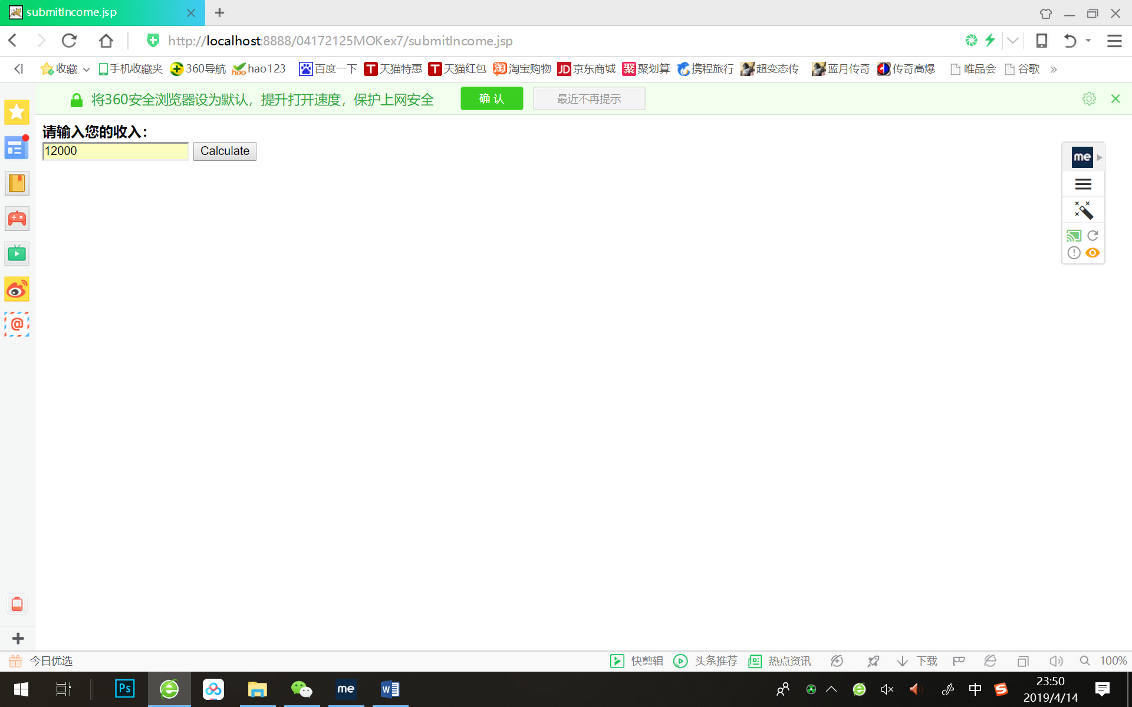 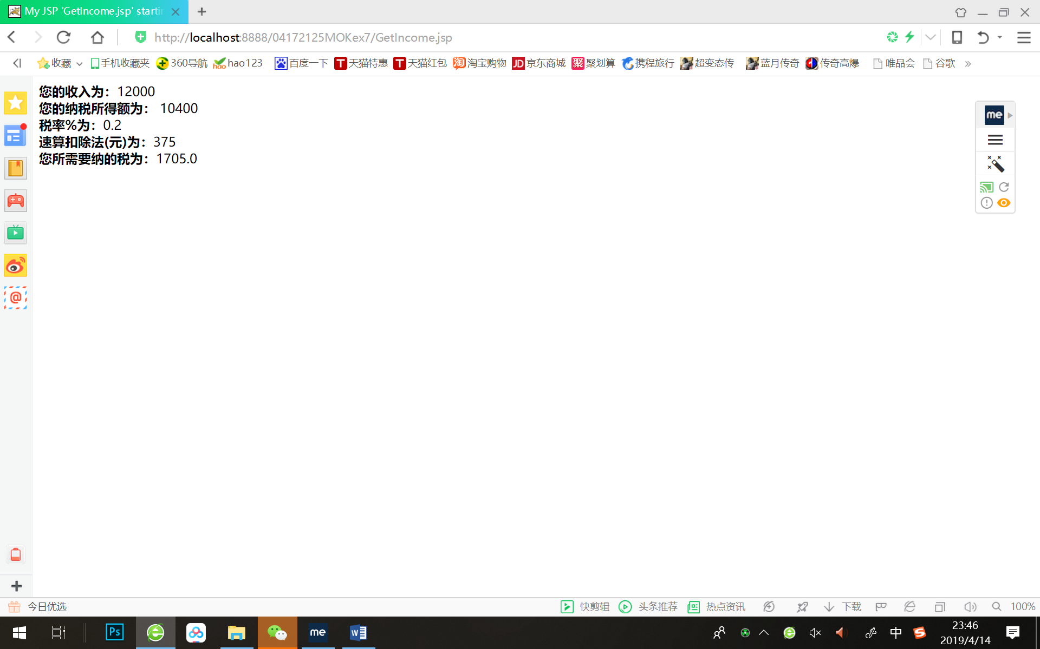

# 收获与问题

1. 越来越熟悉运用MVC模式的方法去写代码，但是还是没有完全吃透。希望在接下来的课程中彻底掌握运用MVC模式去写代码吃力问题。
2. 学习到了如何创建一个JavaBean类，和如何在jsp中运用<jsp:useBean/><jsp:setProperty/><jsp:getProperty/>来调用JavaBean类中setter与getter方法来设置或获取值。